# How to watch video on high definition: Steps:

1. Click on ‘**Settings’** icon

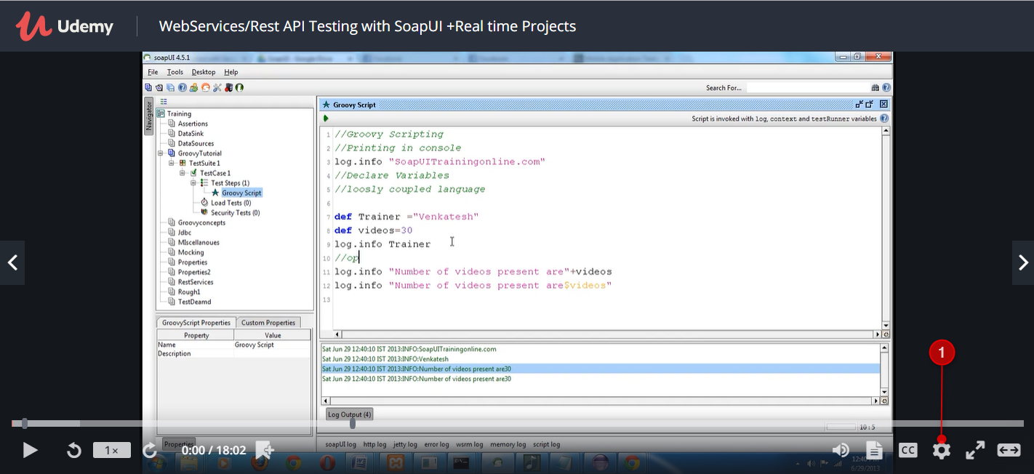

1. Select video resolution as ‘**HD or 720p**’ (Note: Make sure you see red dot beside screen resolution after clicking on it).

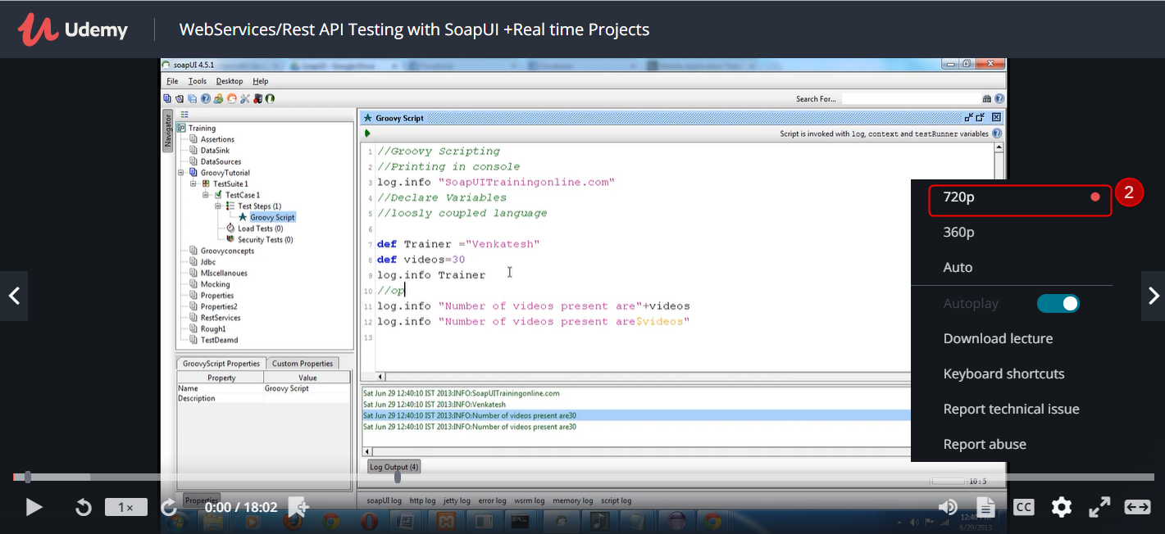

1. Click on ‘**Play**’ button to watch videos in 720p resolution

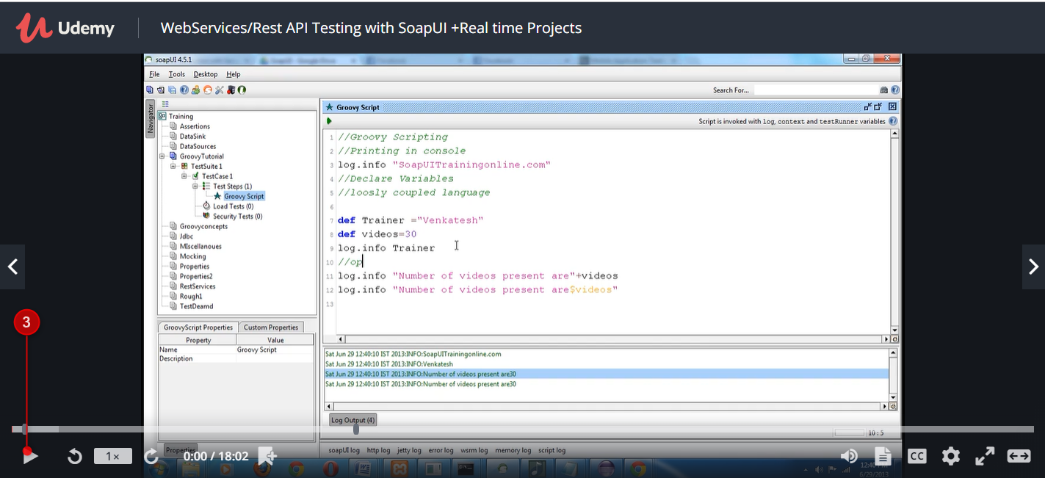

**Recommended**: Watch videos of every course on HD/720p video resolution.

# How to watch video in full screen mode:

**Steps:**

1. Click on ‘Fullscreen’ icon

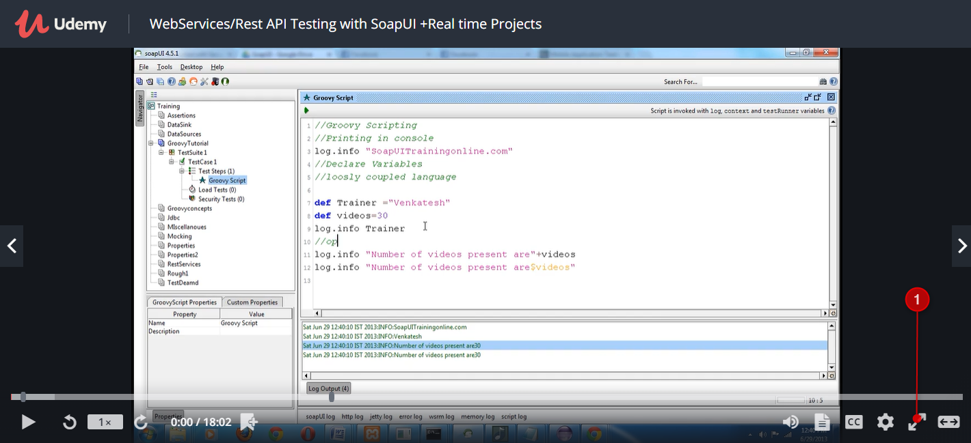

1. You will able to see the video in full screen

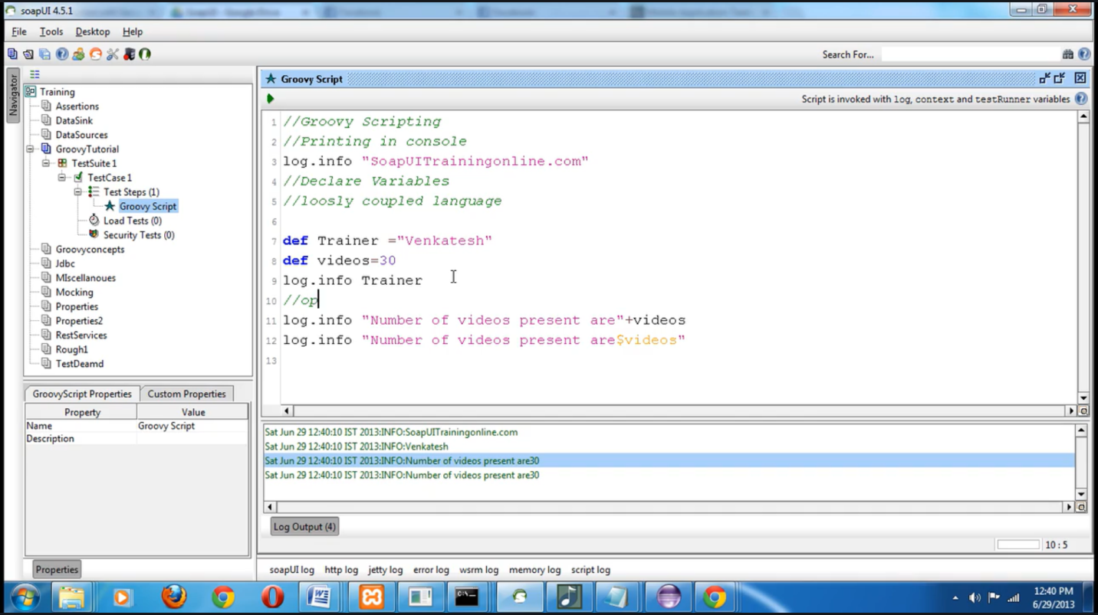

1. Press ‘**Esc**’ key from keyboard to exit from full screen.

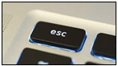

**Recommended**: Watch videos of every course in full screen mode.

# How to increase volume:

**Steps**:

1. Mouse hover on ‘**Volume**’ icon. You will see volume bar pops up.

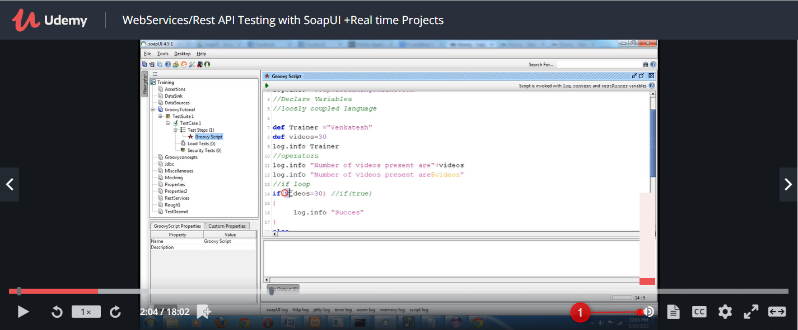

1. Drag the volume bar up to increase the volume.

